Deapth First Search (DFS)
Aim
To implement Depth First Search (DFS) algorithm using Python.
Objective
To traverse a graph by exploring as far as possible along each branch before backtracking and find the path from a starting node to a goal node.
Algorithm
- Start from the given source node.
- Add the source node to the stack.
- Mark the source node as visited.
- Remove the top node from the stack.
- Check whether the current node is the goal node.
- If the goal is not found, add its unvisited adjacent nodes to the stack.
- Repeat the process until the goal node is found or the stack becomes empty.
- Display the DFS path.

Flowchart
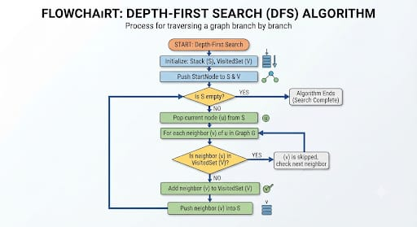

Python code:
graph = {}

n = int(input("Enter number of nodes: "))

for i in range(n):
node = input("Enter node: ")
neighbors = input("Enter neighboring nodes separated by space: ").split()
graph[node] = neighbors

start = input("Enter starting node: ")
goal = input("Enter goal node: ")

stack = [[start]]
visited = set()

while stack:
path = stack.pop()
node = path[-1]

if node == goal:
print("DFS Path:", " -> ".join(path))
break

if node not in visited:
visited.add(node)

for neighbor in reversed(graph.get(node, [])):
if neighbor not in visited:
new_path = path + [neighbor]
stack.append(new_path)
else:
print("Goal node not found.")

Output
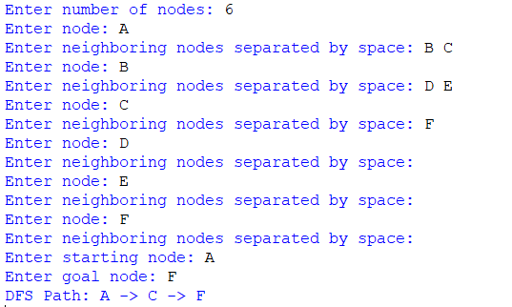
Result
The DFS algorithm successfully found the path from the starting node to the goal node.
Conclusion
The Depth First Search algorithm successfully traversed the graph by exploring one branch deeply before backtracking and finding the goal node using a stack-based approach.

